The Human Harness
Why AI-native systems still need a UI that humans can reason through
DOMAIN CLAIM PROTOCOL SERIES | PART 5
Grounded in the current Unfurl Studio / Fabric design docs
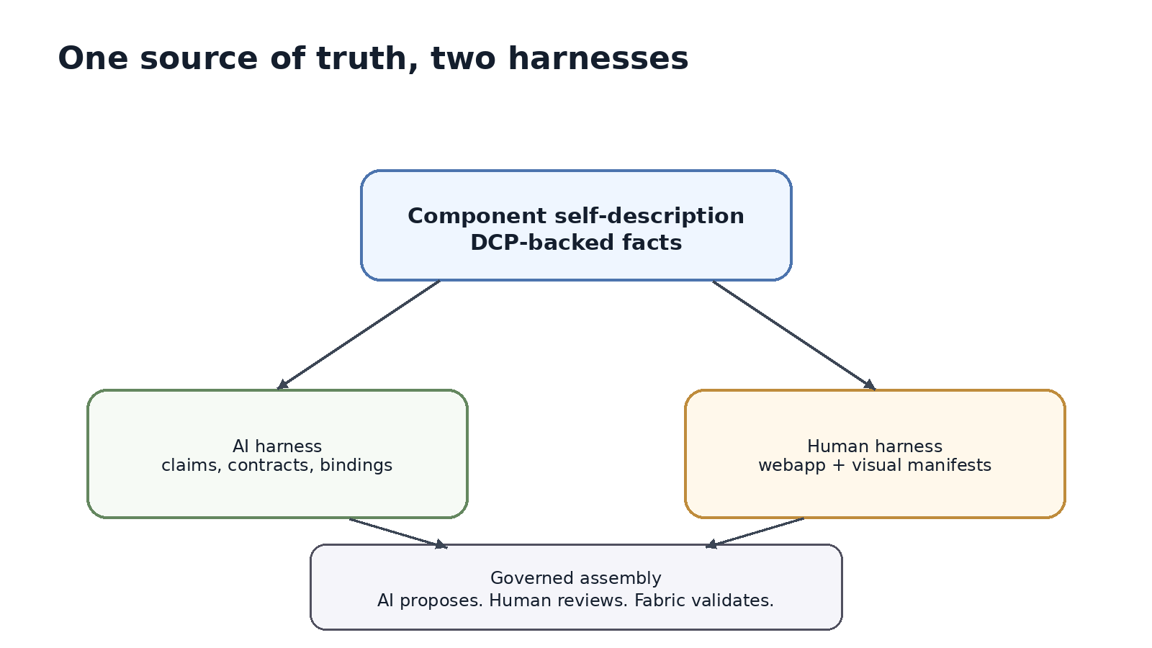

Series context
In the earlier parts of this series, we started with a missing layer: a harness that allows AI to understand what components are, what they can do, what they refuse to do, and how they can be safely composed. Part 4 moved that idea closer to a draft protocol: DCP as a way to make capabilities explicit, negotiable, and contract-bound.
Part 5 completes another side of the story. If DCP is the AI harness, then there must also be a human harness. Not because humans need to micromanage every AI decision, but because every meaningful system still needs human review, human intent, human accountability, and human imagination.
The human harness is not merely a dashboard. It is the surface through which people can inspect, manipulate, validate, and govern AI-native assemblies without losing the underlying truth.

The clue was already in the schema
If you look closely at the DCP-facing material we discussed in Part 4, some fields do not look like they are meant only for AI. Shape, fallback form, visual category, port anchors, connector shapes, interaction handles: these are not fields an AI needs in order to reason about capability compatibility. They are fields a human needs in order to see capability compatibility.
That distinction matters. A system that only describes itself for AI becomes powerful, but difficult to trust. A system that only describes itself for humans becomes usable, but brittle and manual. The deeper idea is that a component should carry one source of truth, with multiple projections. One projection makes it legible to AI. Another makes it legible to humans.
This is why the human harness should not be bolted on after the protocol is finished. It is already implied by the protocol. DCP needs a way to describe what is true. Humans need a way to review that truth, manipulate it safely, and understand what changed before anything is allowed to run.
Figure 1. The same component description projects into both AI-facing and human-facing harnesses.

From GUI to human harness
The GUI was one of the great human harnesses of computing. It did not change what software could do at the machine level, but it changed who could use it and how safely they could reason about it. People no longer had to remember every command, every flag, and every hidden state. They could see files, windows, buttons, errors, and relationships.
But AI-native systems require something deeper than the old GUI. The interface cannot simply expose buttons over functions. It has to expose relationships: what owns what, what depends on what, what is missing, what is refused, what is trusted, what is bound, and what will be signed into an executable contract.
A normal UI hides complexity. A human harness must reveal the right complexity at the right level. It should not drown the operator in raw YAML, logs, or graph data. It should turn the system into something a human can inspect spatially, semantically, and procedurally.

Unfurl Studio: the human harness
Unfurl Studio is the product expression of this human harness. It is the design-time surface where operators can compose intelligent components visually, inspect the DCP facts behind them, and export the same signed contract that the non-visual pipeline would produce.
Unfurl Studio is one product expression of this pattern, not a requirement of DCP itself. The protocol stays product-neutral: another authoring surface can project the same claims, contracts, runtime bindings, faults, and review questions if it preserves DCP as the source of truth.
The important part is what Studio is not. It is not a free-form diagramming canvas. It is not a place where moving shapes magically creates a contract. It is not a shortcut around DCP, Fabric, trust policy, or compatibility validation. It is a projection of Fabric state into a form that humans can work with.
That distinction gives Studio its integrity. The human moves shapes, connects ports, asks the advisor for help, or reviews a suggested change. But Fabric validates the intent. DCP decides compatibility. The signed contract comes from the compiler, not from serializing the visual scene.
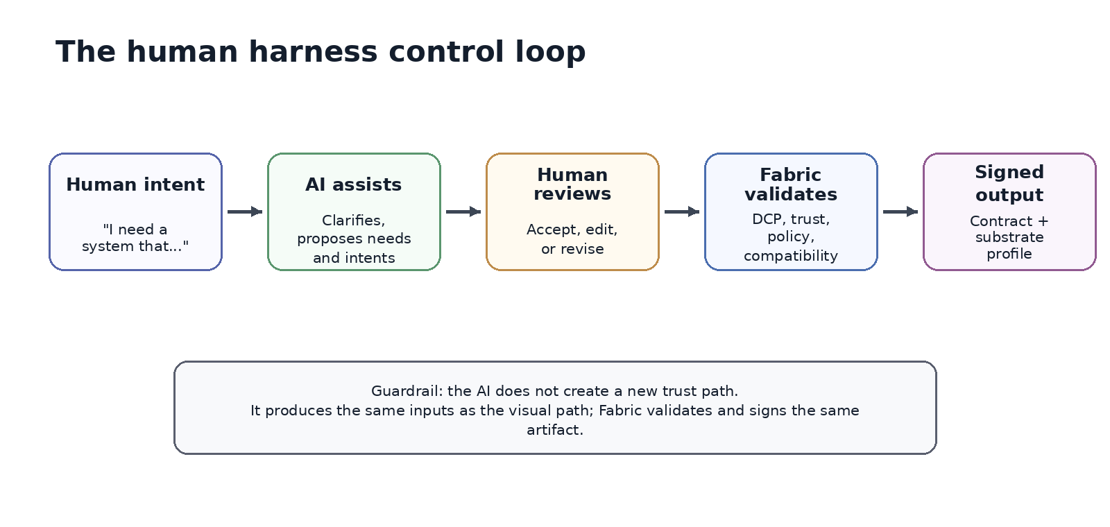
Figure 2. A human harness keeps AI-assisted authoring inside the same governed pipeline.

Why visual metadata is not decoration
It is tempting to treat visual metadata as cosmetic: a cube here, a socket there, a color hint somewhere else. That would miss the point. Visual metadata is how protocol truth becomes a human affordance.
A port is not just a circle on a box. It can represent an offer, a dependency, a substrate dependency, or a refusal redirect. A pipe is not just a line. It represents a proposed relationship that must be validated. A fallback shape is not just a default graphic. It means every component can participate in the human harness even if its author has not supplied a custom 3D asset.
In that sense, the human harness is inclusive by design. Component authors should not need to hire 3D artists before their components become inspectable. If a component can publish truthful capability metadata, Studio can render an understandable shape, generate handles, and surface validation feedback.
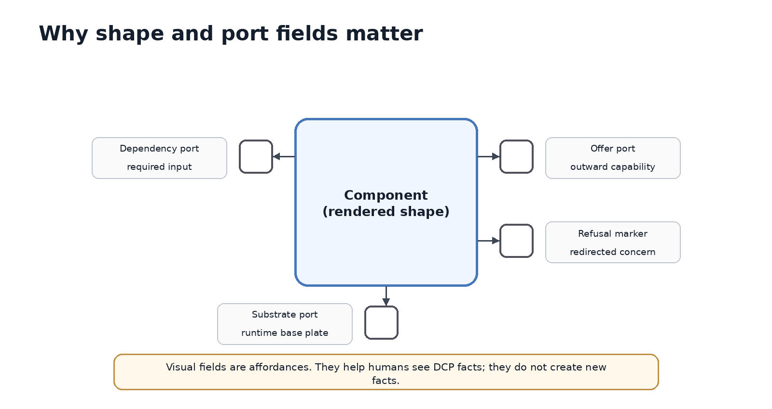
Figure 3. Shape and port metadata are human affordances over DCP facts.

The review loop: AI proposes, human disposes, Fabric validates
The most important sentence in this part may be the simplest: the AI should propose; the human should dispose; Fabric should validate.
This is not anti-AI. It is how AI becomes useful in serious systems. An AI assistant can clarify requirements, turn vague intent into structured needs, suggest components, propose connections, and explain gaps. But it should not create a hidden trust path. It should not hallucinate components. It should not bypass the admitted catalog. It should not sign artifacts on the strength of its own confidence.
A healthy human harness gives the operator several choices at each step: accept the proposal, edit it visually, ask the agent to revise, inspect the underlying facts, or stop because the system has revealed a gap. The harness converts AI from an opaque generator into a visible collaborator.

A practical review grammar
Question for the human | Visible surface | Source of truth | Validation owner
What is this component? | Component shape, label, inspector | DCP claim identity and domain | Fabric/DCP
What can it do? | Offer ports and capability list | DCP offers | Fabric/DCP matcher
What does it need? | Required sockets, substrate pipes | DCP dependencies and substrate profile | Fabric deployment resolver
What does it refuse? | Capped/redirected handles, warnings | DCP refusals | DCP claim validation
Can this connection exist? | Pipe preview, compatibility glow, rejection reason | Claims, versions, trust policy | Fabric validation
Can I export it? | Compile/export panel | Validated candidate and signed contract | Fabric compiler and signer

The human harness must support multiple ways of seeing
Not every operator thinks spatially. Not every workflow is small enough for a 3D surface. Not every review can happen through drag-and-drop. A serious human harness therefore needs synchronized views over the same truth.
The visual workspace is useful for composition and intuition. The inspector is useful for details. The decision audit is useful for trust and traceability. A 2D or table view is necessary for accessibility, keyboard navigation, large systems, and precise review.
The point is not to make one perfect screen. The point is to make the system reviewable through multiple lenses while preserving the same model underneath.
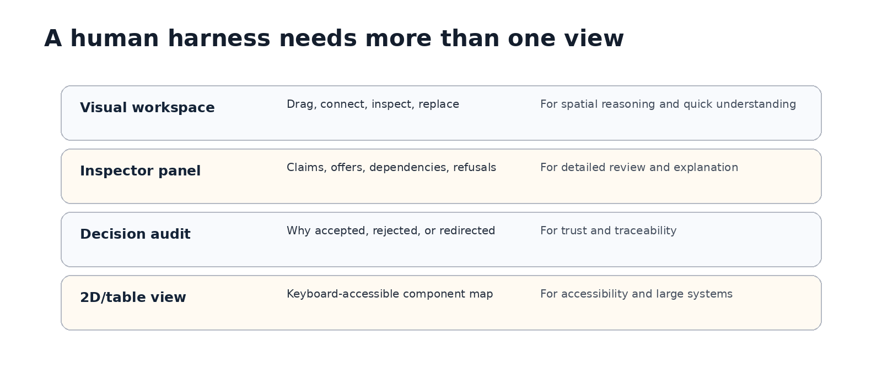
Figure 4. A human harness should provide synchronized views over the same governed state.

Why this matters for trust
The more capable AI becomes, the more important reviewability becomes. A system assembled by AI may be technically valid and still be hard for a human to trust. The operator needs to understand not only the result, but the reason the result exists.
Why was this identity provider selected? Why was that storage provider rejected? Why is this dependency routed through the substrate? Why is the audit concern refused by one component and redirected to another? Why is this shape deployable in one environment but not another?
Those are not decorative questions. They are governance questions. They are the questions that determine whether humans can safely delegate assembly work to AI without surrendering judgment.
In today's tooling, much of this review happens through scattered logs, YAML files, CI output, ad hoc diagrams, cloud consoles, and tribal memory. The human harness brings those relationships into one semantic surface. It does not remove technical depth. It makes depth navigable.

A small example: composing a document-answering assistant
Imagine an operator asks for a document-answering assistant that reads internal docs, uses an approved model provider, stores embeddings in a customer-controlled store, and escalates uncertain answers to a human queue.
In a purely conversational tool, the AI might return an architecture diagram and some generated configuration. Useful, but not enough. In a human harness, the AI first clarifies requirements, proposes a needs spec, and suggests a composition. Studio then shows the actual admitted components: a RAG component, a storage provider, an approved model gateway, an audit sink, an approval workflow, and the required substrate services.
The operator can click the model gateway and see whether it is customer-provided or external. They can inspect the storage dependency and see whether credentials are referenced rather than embedded. They can see a refusal: the RAG component does not own authorization decisions; that responsibility belongs elsewhere. They can try a connection, see it rejected, and read why. When the assembly validates, they can export the same signed artifact that the compiler would have produced outside the UI.
That is the human harness at work. It does not make the system less technical. It makes the technical truth visible enough to govern.

The principle: visual does not mean vague
Many technical people distrust visual tools because visual tools often become informal. Boxes and arrows drift away from what actually runs. Diagrams become stale. The UI looks friendly but the system of record lives somewhere else.
The human harness has to avoid that failure. Visual must not mean vague. Visual must mean grounded. Every handle maps to a declared capability, dependency, substrate dependency, or refusal. Every semantic action becomes an intent. Every accepted intent is validated. Every export comes from the compiler. Every artifact stays tied to the same source of truth.
This is the difference between a diagramming surface and a governed composition surface. A diagram lets a human describe what they hope is true. A human harness lets a human manipulate what the system knows is true.

Bridge to Part 6: aggregation and semantic zoom
Part 5 explains why AI-native systems need a human harness. Part 6 will explain why that harness must support aggregation.
A single component is only the beginning. A home can be an aggregate of climate, lighting, water, security, and energy systems. A colony can be an aggregate of homes. A city can be an aggregate of colonies, public systems, grids, transport, utilities, and governance surfaces. At every level, the human harness must let people zoom in for detail and zoom out for abstraction.
This is where the map analogy becomes important. When you zoom out, you do not want every screw, wire, tap, sensor, model, queue, and API call. You want a meaningful abstraction. When you zoom in, you want the details to reappear in the right place. Aggregation is how intelligence scales; semantic zoom is how humans stay oriented.
The next question is not only how components compose. It is how composed things become components in their own right.

